**Step 1** – start 2 docker containers, ideally one only but I don’t know which conatainer exactly-

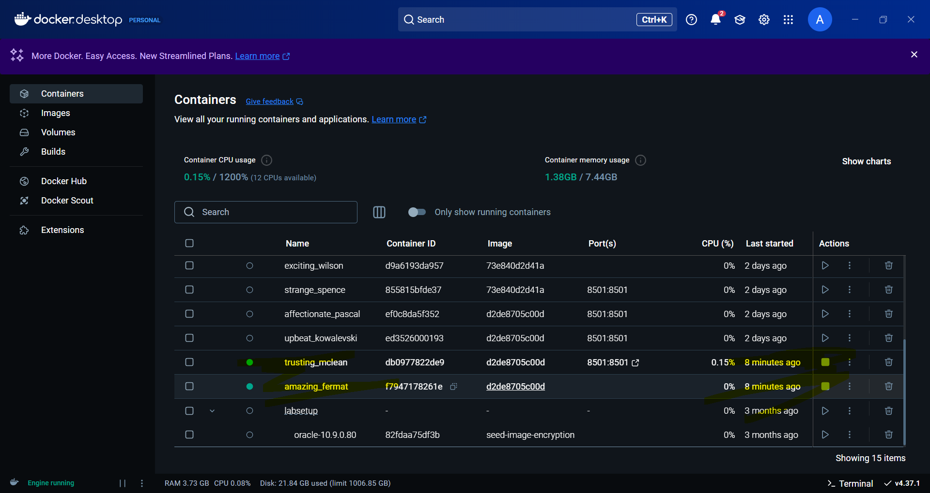

**Step 2-** In railway > deplyments > public domain you’ll get public accessible link:

cnnclassfiermnist-production.up.railway.app

**Step 3-** Start Railway container.